The Fabulous Girls Fun Tour Itinerary

2nd September 2019 – Sydney to San Francisco
Welcome to The GFT – Girls Fun Tours. Meet with your Tour Hostess, and our travellers at the
Sydney International Airport. We will pick a designated meeting point at 2.40pm for your flight to
San Francisco at 5.40pm, QF73 operated by Qantas (we will be arriving to San Francisco on the same day
at 4pm due to the time difference) Sit back, relax and enjoy the inflight entertainment as we make our way to USA.

DAY 1, Monday – Welcome to San Francisco

Welcome to San Francisco! “City of Bay” and cultural gem of the West Coast.
Upon arrival this afternoon we’ll be transferred by our private coach to our luxurious Westin St Francis Marriott, San Francisco for the next 3 nights located in the heart of the city. Take in panoramic views of San Francisco from The View Lounge, Marriott’s popular rooftop bar open for sunset and evening drinks.
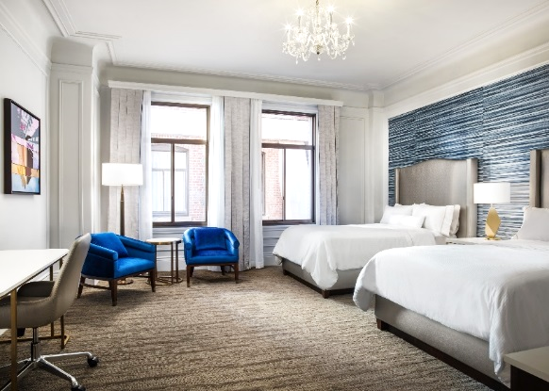
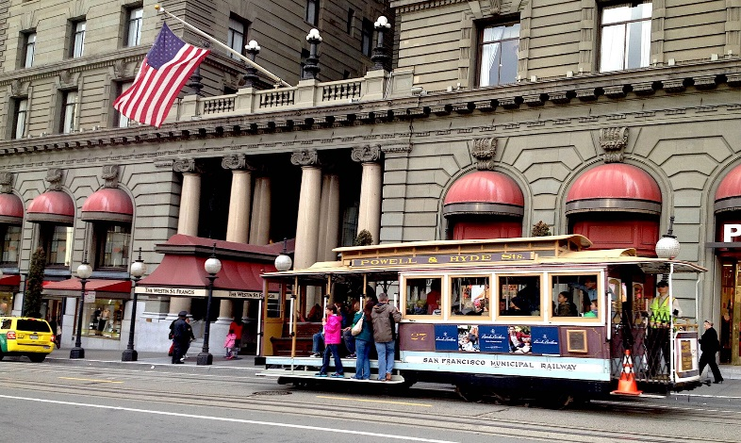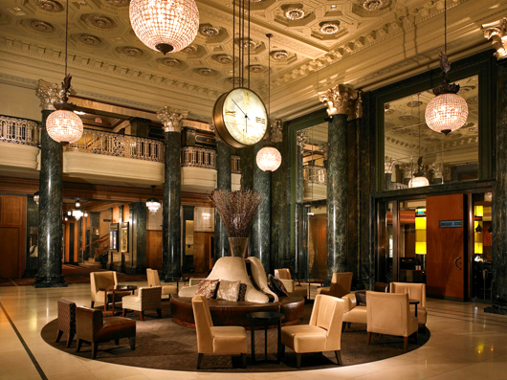
This afternoon we will have time to relax and explore Fisherman's Wharf with its quirky shops, cafes and endless entertainment.
We will meet in our lobby at 5.15pm and head out to catch the very iconic Cable Car to Fisherman’s Wharf where you can browse through the shops, take a picture with the famous San Francisco Seals at the Pier 39 or watch the sunset over the Alcatraz Island. Followed by “Welcome to the USA Dinner” at Bubba Gump; the Shrimp Company Restaurant is an American seafood restaurant chain inspired by the 1994 film “Forrest Gump” with Tom Hanks. After dinner we will come back to our hotel for an early night rest or it is yours free to explore.
Meals: Dinner -Bubba Gump

Twin Double Bed room (no specific views)

DAY 2, Tuesday - Tour San Francisco
Today is all about exploring this most picturesque city in the company of our fabulous local guide from Towers Tours or Dylan’s Tours (subject to availability)
We suggest you have breakfast before the tour (please stay local). After breakfast we will meet in the lobby at 9.30am to get aboard minibus for a guided tour of San Francisco’s highlights with full narration.
Allow the knowledgeable local tour guides to escort you through a tale of many charms and attractions with history of San Francisco & its surroundings.
The tour highlights include Fisherman’s Wharf, North Beach, historic Presidio National Park with its spectacular vistas, elegant Nob Hill, the Palace of Fine Arts, the famous Mrs Doubtfire House (The 1993 film with Robert Williams), look out over Golden Gate Bridge to Alcatraz Island, and a stop at Twin Peaks for panoramic views (weather permitting), Chinatown - San Francisco’s Chinatown is the oldest Chinatown in North America and the largest Chinese enclave outside Asia. It is the oldest of the four notable Chinatowns in the city. According to the San Francisco Planning Department, Chinatown is "the most

densely populated urban area west of Manhattan", with 15,000 residents living in 20 square blocks.
The photo stops are many & will include: historic Alamo Square offering quintessential scenes of the City, including the famous 'Painted Ladies' of Postcard Row. After crossing the Golden Gate Bridge, we will head to the charming bayside city called Sausalito.
This artisan community is reminiscent of the exciting French Riviera and well known as a rich and famous playground for the actors and performers.
Sausalito is filled with quality restaurants, high class boutique-lodgings and many types of colourful sights that are not always found in other sunny California coastal settings. Here we have time for lunch, and or to shop and explore. Enjoy outdoor dining and savour the San Francisco bay view.
Meals: $ your own
At approx. 3.00pm we will meet at the Sausalito Ferry ok, and we will travel across the San Francisco Bay back to Pier 39 at Fisherman’s Wharf to see hundreds of sea lions. Please note the ferry leaves at 3.15pm sharp.

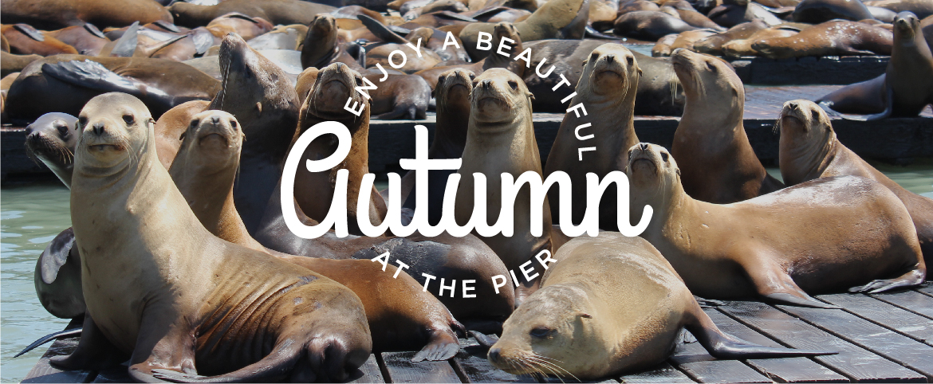

Named the “Number 2 Most Exciting Ferry Ride in the World” by the Travel Writers of America in 2009 you will see along the way on your 30min journey from Sausalito to San Francisco to, you’ll see Alcatraz, Angel Island, and the Marin and Tiburon headlands and get a feel for the scope and history of the famous San Francisco Bay.
Remainder of the day (afternoon) is at your leisure for shopping and restaurants at Fisherman’s Wharf or the retail district at Union Square.

DAY 3, Wednesday - San Francisco Shopping Spree

Today create your own adventure with San Francisco city, relax and explore the surrounds of your perfectly situated hotel - it is all within very easy walking distance!

Whether you want to visit Macy’s or Victoria Secret at Union Square, Nordstrom, Market street full of famous boutiques, or Westfields of SF 9-story mall featuring over 170 shops & restaurants, a multiplex & a dome-covered atrium.

Westfield San Francisco – 300M
Macy’s & Union Square - 20m
Market St full of boutiques – 300m
Union Square – 10m
Cable Car Station – 20m

Please note if you wish to see Alcatraz please make your booking few months in advance to avoid disappointment. These tours are booked far ahead.
This afternoon please meet us in the lobby at 5.30pm where we will head out to our secret location (please do not forget your cameras) as we say farewell to San Francisco after a wonderful few days with farewell cocktails and tapas in a secret location....so let's get a little glamorous and enjoy our evening Ladies!

Meals : $ your own

DAY 4, Thursday – Good bye San Francisco.
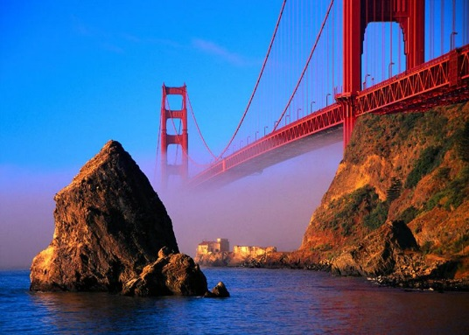
After breakfast at 8.30am we will use private transfers to San Francisco Terminal to board at 11.30am flight UA 5532 operated by United Airlines (subject to change). We will arrive to Vegas around 1pm where we will be collected by private couch and Chauffer directly to our Mirage Resort to relax!

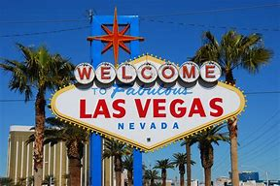

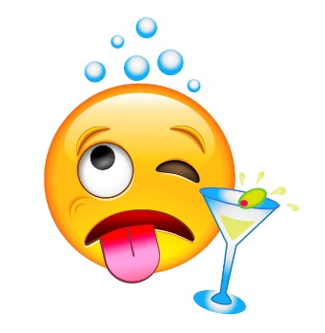
Welcome to Las Vegas! Are we ready?! And do not worry Ladies, what happens in Vegas, stays in Vegas.

Day 4 Thursday (continued) – Las Vegas Welcome to Fabulous City

Welcome to Fabulous Las Vegas
Arrive to the Mirage Resort & Casino by private Limo. The Mirage Resort and Casino is one of the most distinct landmarks on the Vegas Strip, featuring Siegfried and Roy’s Secret Garden and Dolphin Habitat right at your door step of your resort.
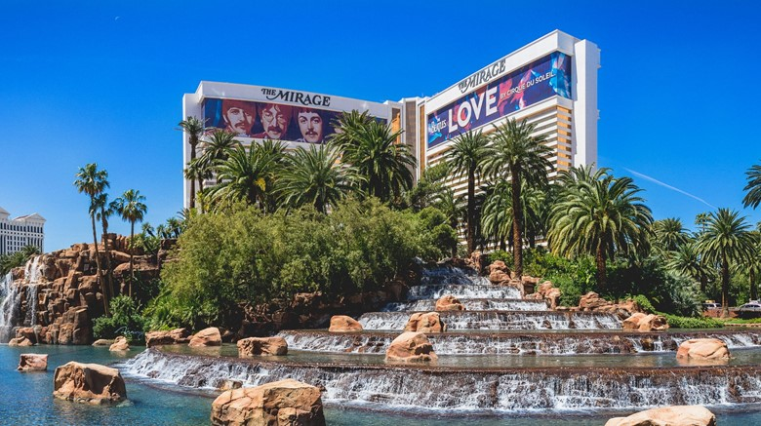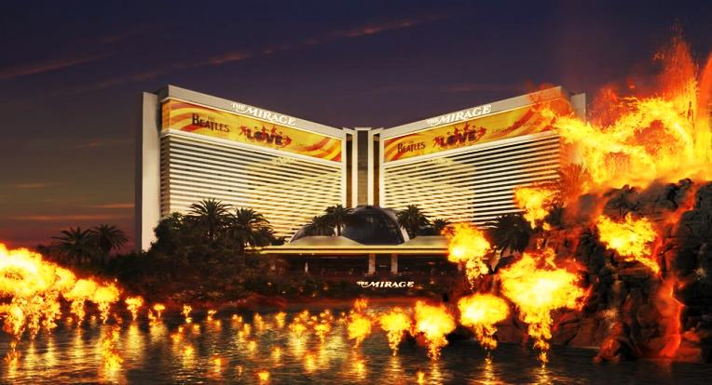
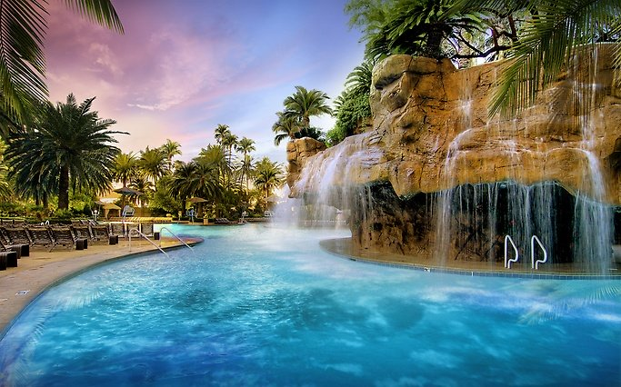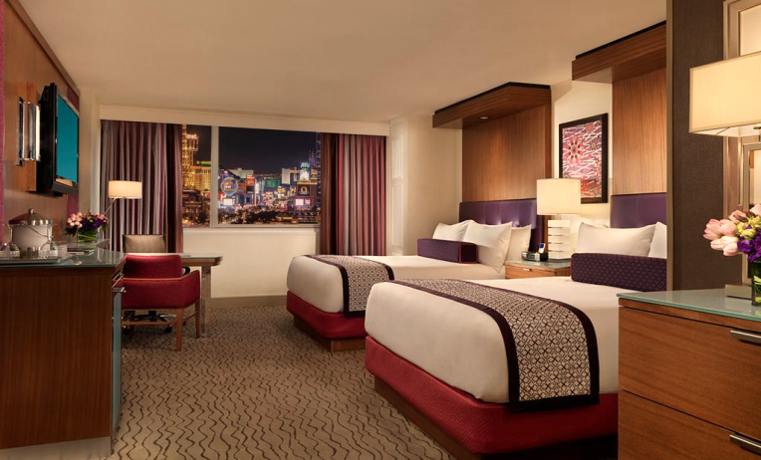
You can discover the Siegfried & Roy’s Secret Garden and Dolphin Habitat which brings you face-to-face with some of nature’s most exotic animals. Discover exclusive experiences that can’t be found anywhere else in Vegas, including a behind-the-scenes VIP Tour or painting with the Dolphins if you wish.
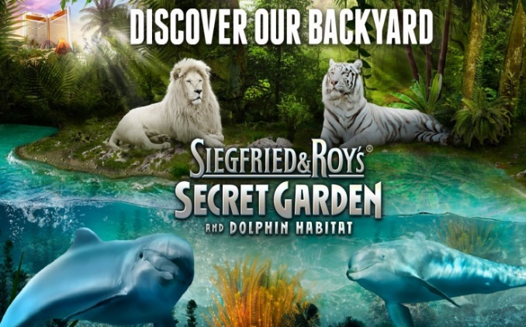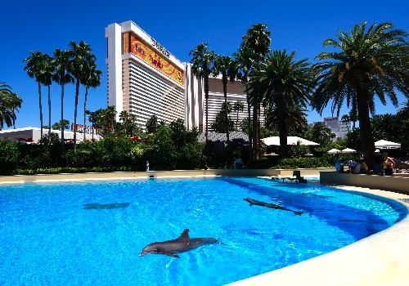
After check-in we will have time to relax & explore the hotel facilities, pool sunset bar and shops.
At 5.30pm we will meet at the Centre Bar located steps away from iconic Mirage atrium for a round of welcoming cocktails – how about an Expresso Martini ($15) and a quick briefing on the next few days ahead. Then, we will have a short stroll to the Gilley’s Saloon Bar and Restaurant for a saloon style dinner, Yeeha! Great menu with smoky BBQ ribs! And great selection of salads and vegetarian dishes.
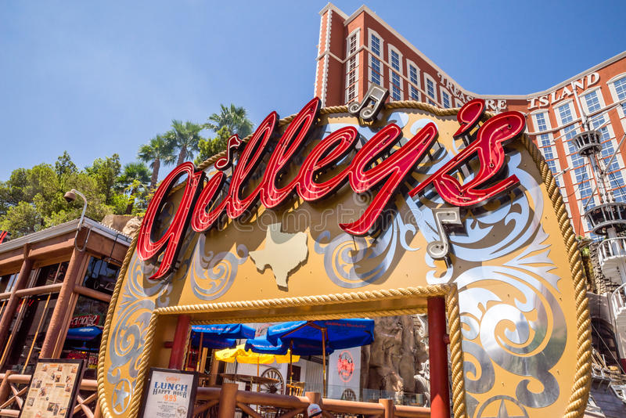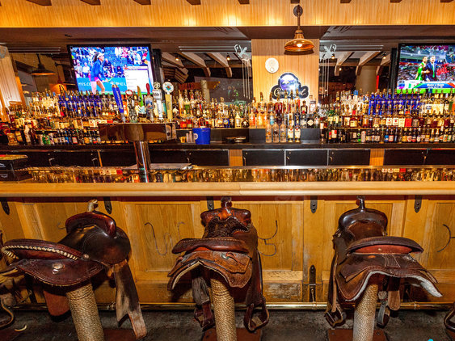After dinner, we will go for a walk to explore the Las Vegas strip at night, full of neon lights and entertainers. We will stop for the iconic Bellagio Fountains featuring a dancing water aquatic show choreographed with music & lights. (Please note: you can separate at anytime and explore on your own).
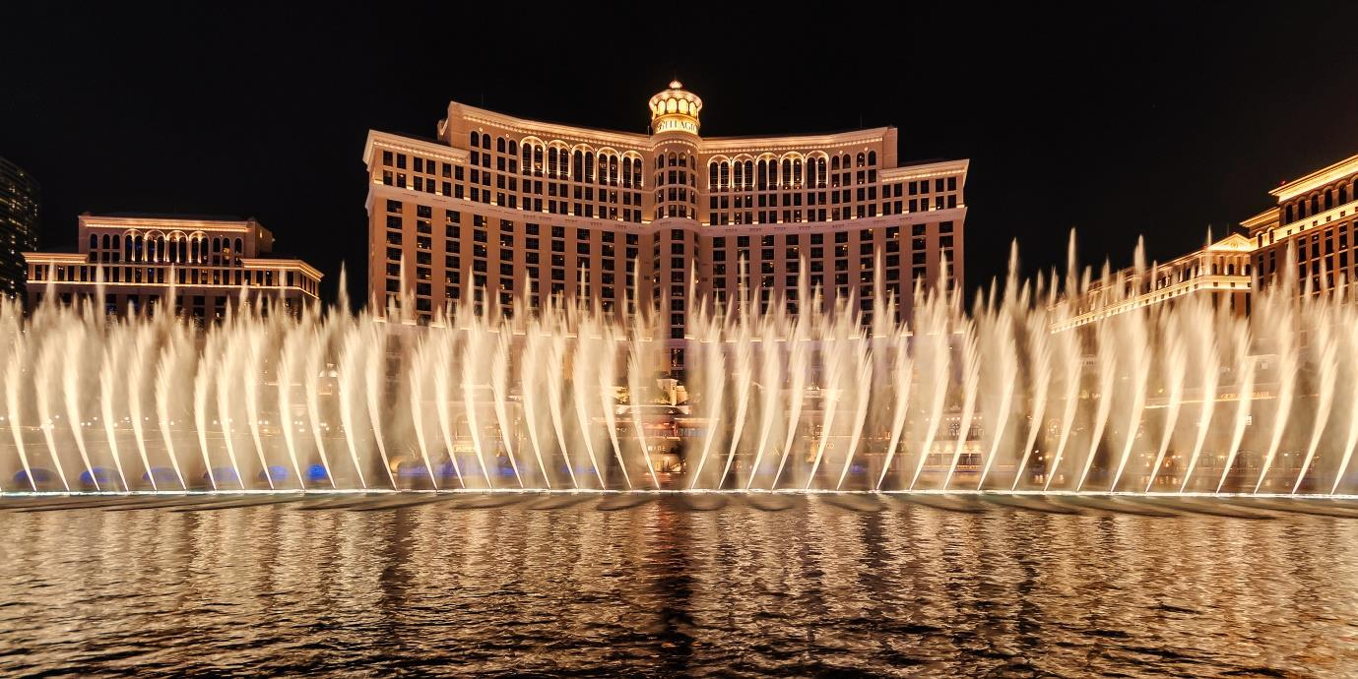
From there as the night is only young. We will provide you with a lot of options… but is only day one. Enjoy a cocktail as you stroll and take in the Vegas strip, people watching as you stroll.
Head back to your Mirage room at your leisure.
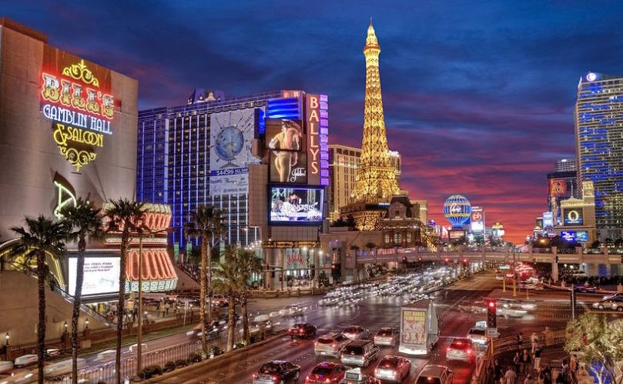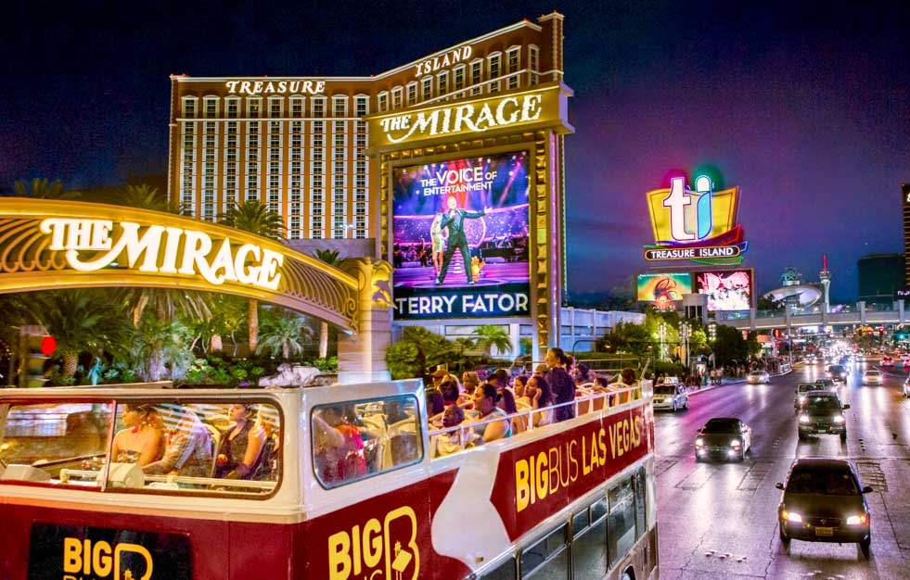
Meals: Dinner - Gilley’s Saloon Style Dinner ($ your own)
Day 5 Friday – Exploring Las Vegas

After breakfast ($ your won) at 9.30am we will all meet for a day tour of the Vergas strip.
We will head across the road to The Venetian. No trip to Venice would be complete without a graceful and romantic glide down the Grand Canal in an authentic Venetian gondola. Float beneath bridges, beside cafes, under balconies, and through the vibrant Venetian streetscape as your singing gondolier sweeps you down the Grand Canal for a ride like no other.
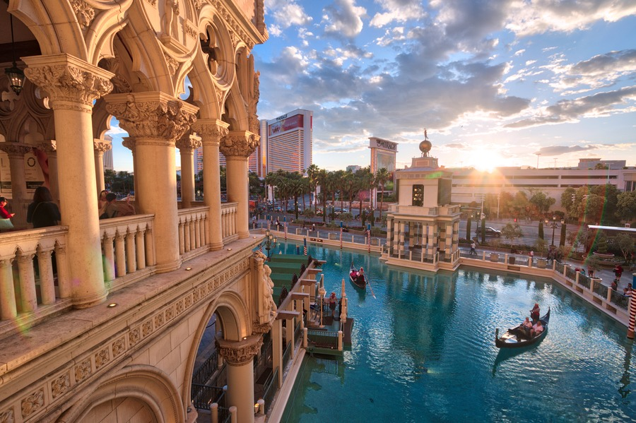
We continue our walking tour of the Las Vegas strip down to the Bellagio Resort. We will visit the Bellagio gardens and review the 5-star luxury interior of this beautiful resort. Then we will head to Caesar’s Palace. Caesars Palace will overwhelm you with its size and its grandeur, there is so much to be in awe about. The sculptures, the art, and architecture made it feel like you were walking into Ancient Greece. Albeit, with some modern upgrades. The highlight for some you will be to wander through the Forum Walk and great stores located there.
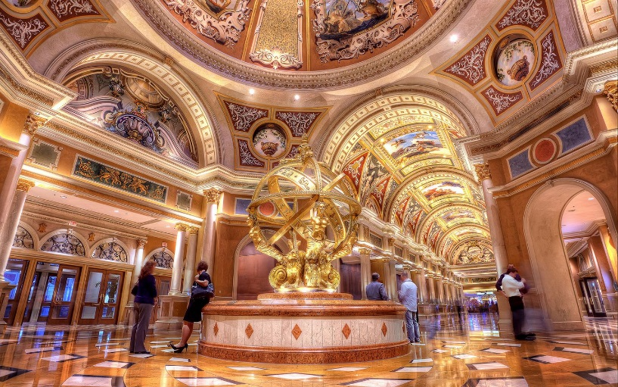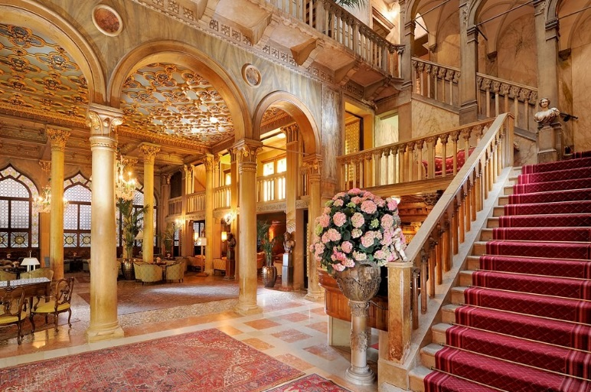
The Forum walk is a shopper’s paradise including Victoria’s Secret, Guess, Boss, Channel, Clarins, Cartier and many more.
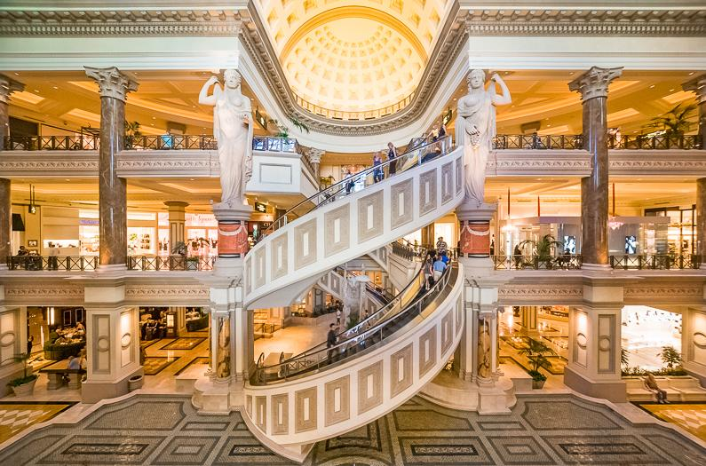

At the Caesars Forum Shops, you can see a masterpiece in motion…. The Spiral Escalators!
Suggestion: take a break and visit the Cheesecake factory located near the colossal fish tanks.
Then, at your leisure, head back to the Mirage Resort – it’s a short walk next door to Caesars.
For those who feel little bit tired you can wander, play the slots, or just take some time out and relax by the pool with a cocktail.
Tonight, please be ready at the Lobby at 5.00pm. We will have a pre-show dinner at the all you can eat Mirage Garden Seafood Buffet with unlimited beer, wine and soft drinks.
Plenty of time to crazy the many food and desert selections so we will meet outside the Buffet not later than 6.40pm.
Tonight’s we take you to a Cirque De Soleil show – we will keep this as a surprise which show it will be.

Show title and location announced on the night.

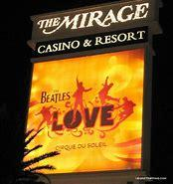
After the show at around 8.30pm you are free to wander the strip or Mirage resort. Do not forget to see the Volcano outside of The Mirage. The Mirage Volcano show is igniting the Las Vegas Strip by combining fire with music and choreography - beautiful and thrilling at the same time. For those who arrive early enough to stand in front, the volcano gets quite warm & toasty.
We strongly recommend you get a good night sleep.
We have a very busy and exciting day ahead – The Grand Canyon Tour.
See you in the morning at 7.30am! Yes 7.30am sharp Ladies.
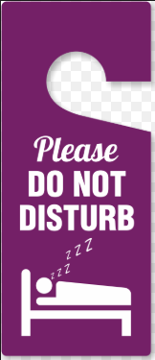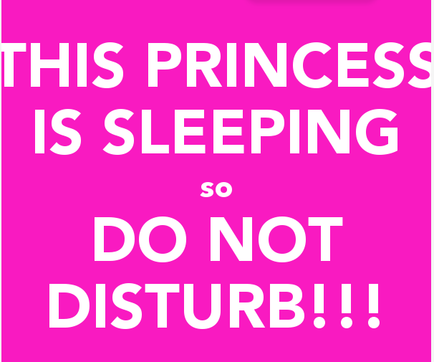
Meals: Dinner at the Mirage (included with alcoholic drinks)

Day 6 Saturday – Las Vegas
Grand Canyon Ultimate GFT Tour!
Experience the majesty of the American Southwest on a guided tour to the Grand Canyon. With a drive through desert landscapes flecked with Joshua trees and stops at impressive sights like Hoover Dam, Eagle Point and home to a Native American village, and Guano Point This day trip is sure to awaken your inner nature lover.

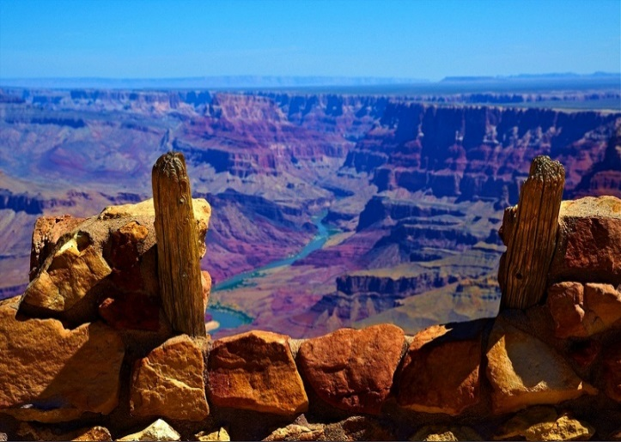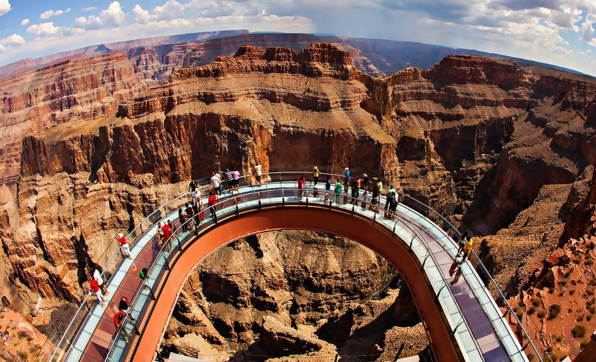

What to expect? From your hotel, board a luxury air-conditioned coach and begin your ride.
Get ready for a fun, exciting and informative tour of the Grand Canyon. This all-inclusive tour begins with a breakfast stop for a hot, sit-down, made-to-order breakfast at about 7:45am, and then it's onto the magnificent Hoover Dam Bypass Bridge for a 20-minute photo stop to take photos of the dam. After that pit-stop, you will continue onto the Grand Canyon where you will have 3.5-hours to enjoy all it has to offer.
Your guide will travel with you to the first stop at the Canyon. There are so many points of interest (too many to detail), so have your comfy walking shoes on today.
The highlights include: visions of the Colorado River, and the canyons beautiful silence and stillness that will engulf you.
We have seen this wonderful site; no photograph or verbal description of the Grand Canyon is ever going to suffice. You just have to experience its overwhelming vastness and awe-inspiring splendor in person.
After your 3.5-hours at the canyon rim and a delightful traditional lunch, we will journey back to Las Vegas by approximately 5pm - earlier than most other tours - which enables you to still take in the sights of this electric city at night. The rest of the night is FREE.
We recommended dinner at Hells’ Kitchen - Gordon’s Ramsay famous steak restaurant!!!

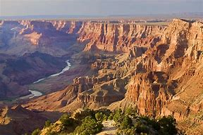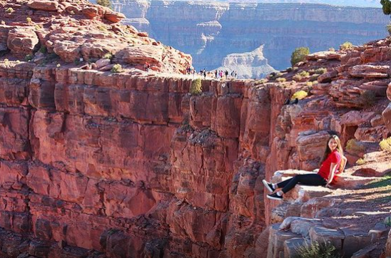
Meals: Basic Breakfast and BBQ Lunch organised by tour operator (included).

Day 7 Sunday – Las Vegas
Breakfast at your own leisure
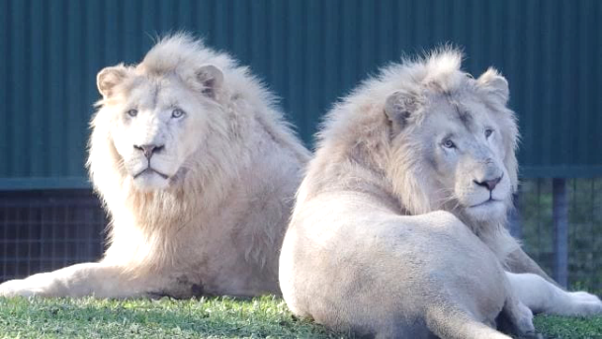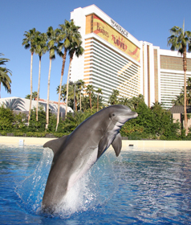
Is this my morning at the pool?

Or is today the day to go to the Secret Garden and see the Dolphin Show or do both.

At 1pm, please meet us at the Lobby and we will all go together for lunch to Paris Hotel, an iconic landmark of The Las Vegas Strip. Here you can explore Parisian shop and enjoy amazing interior skyline and décor.
From here, we only have a short stroll to the Coca Cola Shop and M&Ms World…a MUST SEE! And the rest of the afternoon is free until we meet in the lobby again for an exciting night ahead – The Freemont Street Experience, downtown Las Vegas!
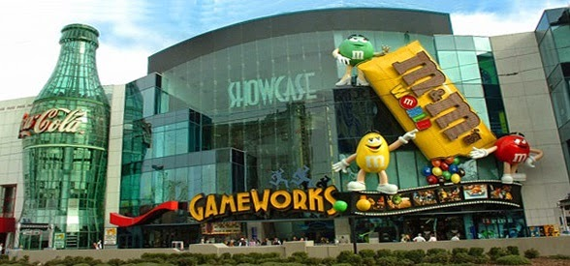
Please meet us in the lobby at 6pm sharp where we will travel in the Luxury super stretch Limo to Downtown Las Vegas sipping on the Champagne, on the way we will stop at the famous Las Vegas sign! and iconic Graceland wedding chapel for a photo opportunity!
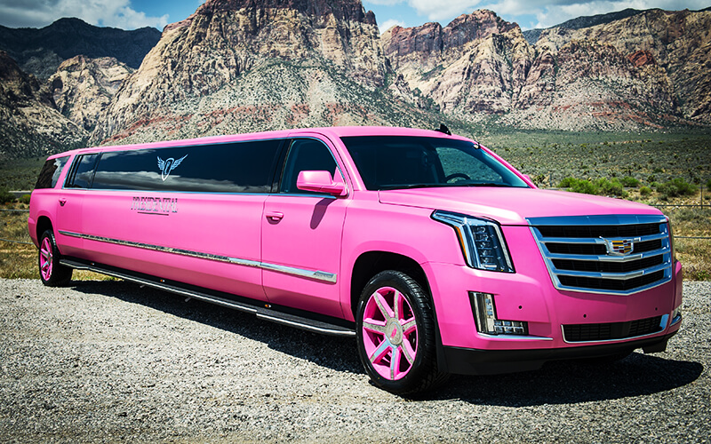
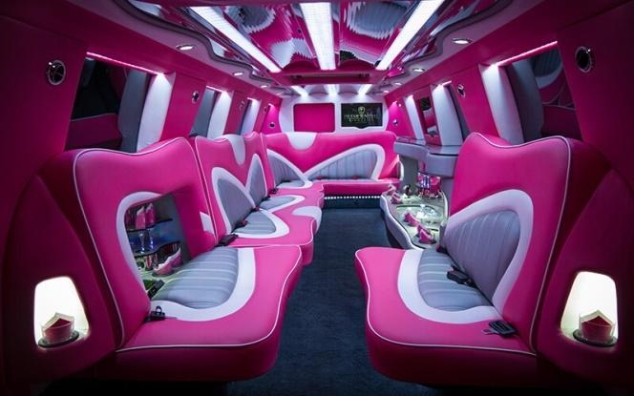

Once we arrive at Las Vegas downtown, we will head out to a very unique character theme restaurant for a one of a kind dinners…we will not reveal the name in case you want to google the restaurant, but it will be a great meal & a loads of fun!
After dinner let’s explore the Freemont Street. Fremont Street Experience is an incredible entertainment destination in the heart of the world’s most exciting city, Las Vegas.
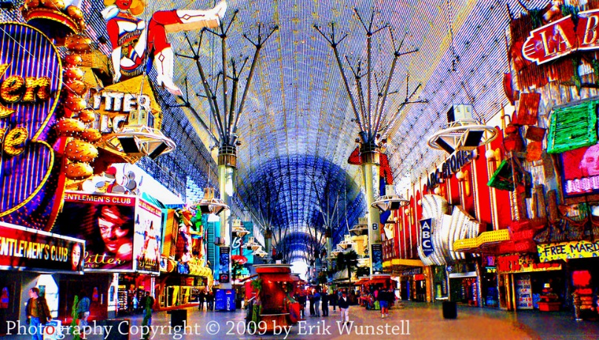
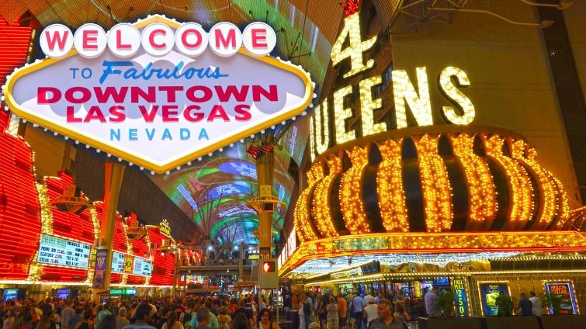
You can walk around, look at the street entertainers, have a few cocktails or try your luck in the casinos like Golden Nugget, Queens or Bullion. LV Downtown is the original town site and was the gambling district of Las Vegas prior to the Strip. Let’s have some fun.

Meals: Lunch @ Paris Hotel & Casino or your won choice ($ your own) we should have some discounted offers on the day.
Dinner @ Surprise Theme Restaurant ($ your own) – it is not expensive but lots of FUN FUN FUN!!!

Day 8 Monday – LAS VEGAS, Ladies it’s time to Shop till you Drop

We recommend breakfast at the Mirage.
Ladies, this is it, it is your day to shop till you DROP!! The GFTs are going to the Premium Shopping outlets!!
We also prepared something very special for tonight as this is our last night in Vegas and we are going to finish it off with a BLAST!
Please meet at 9.30am in the lobby and we will go to shopping outlets paradise by private coach. We have most of the day here so please do not stress, return to your hotel by taxi at your own pace (taxi share cost roughly $25 USD).
Tonight, lets meet in the lobby at 5.30pm, we have a Special Surprise for you later on in the evening. We will have private transfers to Mandala Bay Resort. Here we will pause for a light dinner of your choice. Enjoy your food, relax and sip on cocktails.
After dinner for something different, you will escape the heat of the strip and head into the iconic Minus 5 Ice Bar, the coolest unforgettable experience where everything is made out of Ice!!!
That’s right, the walls, the chandeliers, the seats and even the glasses that you enjoy your beverage in. Vegas will be hot at this time of year, so this visit will be a great cool change.
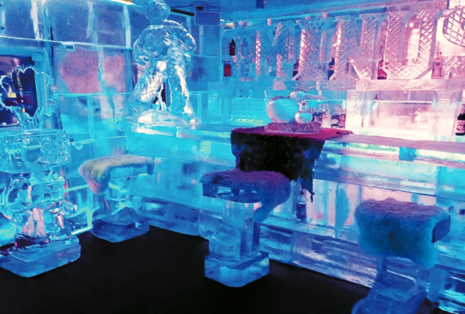
Once we arrive, we will be given Faux Fur Coat, gloves, fur hat then transported into a winter wonderland of interactive ice architecture while sipping the coolest beverages from glasses made entirely of ice. Your entry also includes a cocktail!

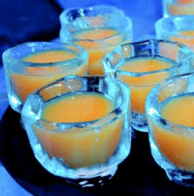
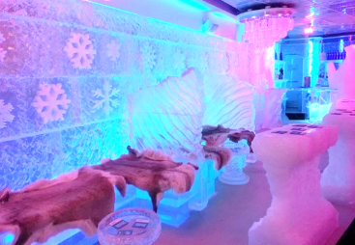
An exciting LED light show and upbeat music plays while you take in the pristine surroundings and explore the different ice sculptures and themed ice rooms. Another great spot for some fun, and photos

Once we complete our fun in the Minus 5 Bar we will head to the lobby of the Hotel where we will be taken by private coach to the helicopter terminal.
Our V.I.P tour highlight - immerse yourself as you take in the best view of the Vegas strip, the perfect foundation for a Vegas experience you’ll never forget.
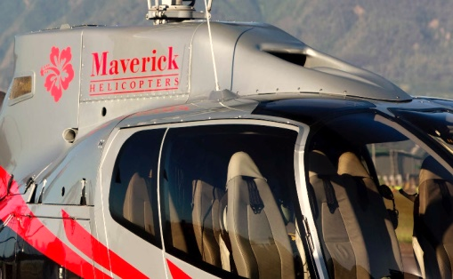
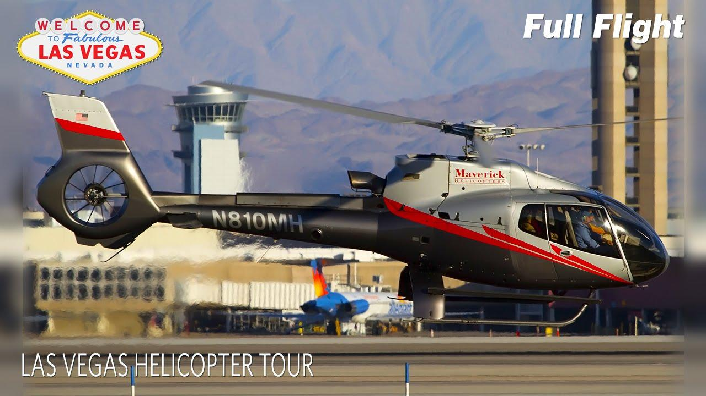

You can tour Las Vegas from a bus or walking the streets. You can climb the Stratosphere Tower to see it from above, but nowhere else can you experience a view of Las Vegas from the sky like this one, on board a limousine of the sky, Maverick helicopter flying high above Sin City.
Enjoy a complimentary glass of Champagne, and then climb aboard a luxurious state of the art 7seat Mustang helicopter, the limousine of the sky, operated by Maverick Aviation Company. (Wraparound windows provide superior visibility).
Sit back and soar over the dazzling Las Vegas Strip. Once in the air, fly over the casinos and resorts of the Las Vegas Strip, from the New York-New York skyline to the Bellagio fountains and the 315,000-watt light beam of the Luxor Resort pyramid.

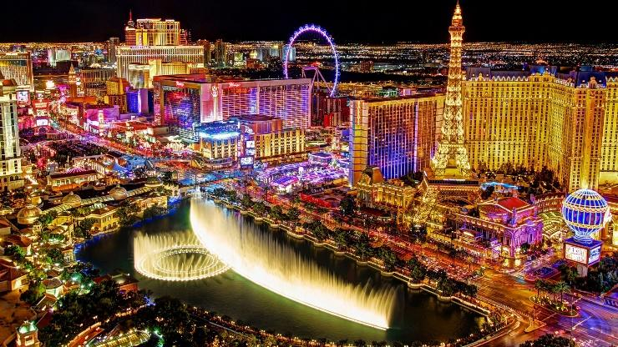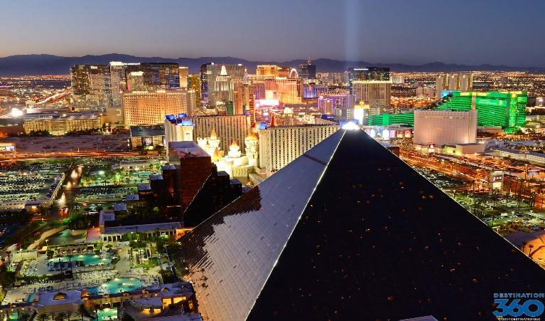

This flight is one very special Girls Fun Tours VIP memorable experience

After our helicopter flight we will be taken to the Luxor Resort, one of the most recognizable resort in Las Vegas is the 30-story pyramid and Sculpture of Egyptian Sphynx…get your camera ready. Luxor is the sixth-largest hotel in Las Vegas and the ninth-largest in the world!
At 42.3 billion candelas, the Luxor Sky Beam is the strongest beam of light in the world, using curved mirrors to collect the light from 39 xenon lamps and focus them into one intense, narrow beam. On a clear night, the Sky Beam is visible up to 275 miles (443 km) away.
After photos we will walk inside the Luxor to experience the architecture.
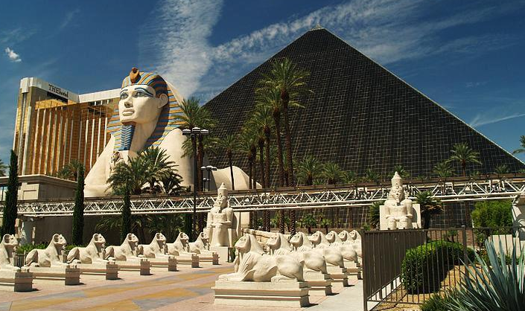
Meals included: ($ your own)
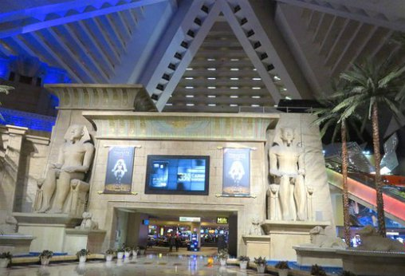

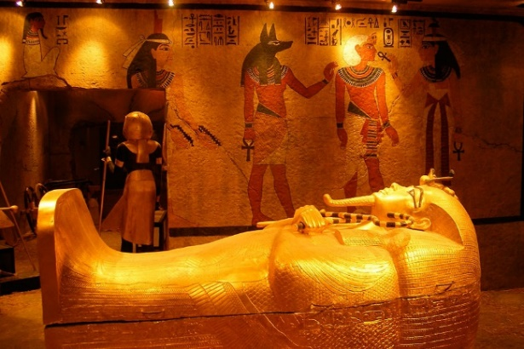

From the Luxor hotel, you are free to do whatever you want for the rest of the night. Perhaps you want to go to New York New York Hotel & Casino (across the road) and try a roll caster ride going in and out of the casino or "If you enjoyed the movie", then you may love this "crazy-wild" New York-New York spin-off of the Gotham saloon, where "bodacious babes" "dance on the bar" while "handing out shots, shots and more shots” – are you up for a fun finish at the Coyote Ugly Bar for final drinks!
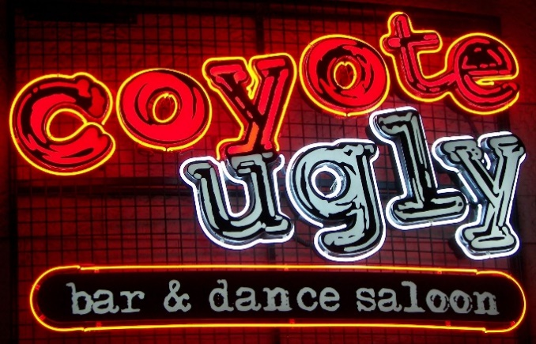
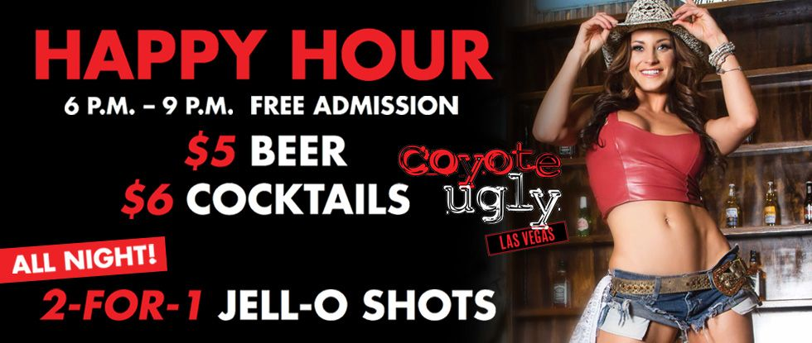

Meals : (your own$)

Day 9 Tuesday – Las Vegas to Sydney via Los Angeles (stopover optional)
After breakfast (your own time $) please meet at the lobby and we will store your luggage as our flight is not till late afternoon.
Today is our last day in Las Vegas, so you may simply chill by the pool and relax after a very busy few days and do ABSOLUTELY NOTHING, perhaps have a massage at The Mirage Spa.
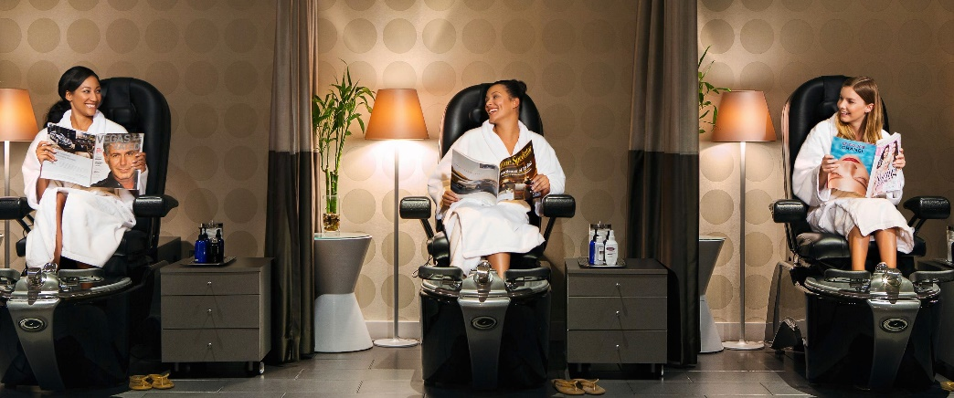

But for those who still feel energetic you may want to do last minute souvenir shopping, or do something you wanted to do earlier, the choice is yours, totally up to you.
Please meet in the lobby at 5.00pm for our transfers to LAS VEGAS airport.
On the way to the airport we will stop for the very last time at the Las Vegas sign but this time from another side where it says: “Drive carefully come back soon”
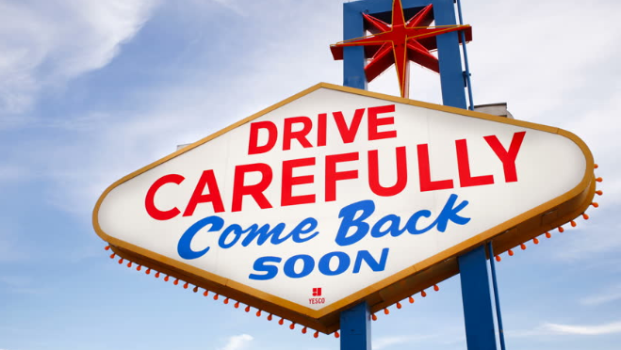
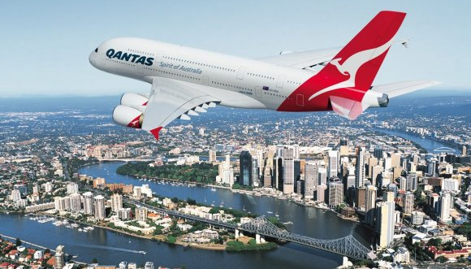

At the airport, after checking in, we will board our interconnecting flight operated by Alaskan Airlines to Los Angeles. Once we arrive in LA we'll have time to get a “snack bite” and relax at the terminal awaiting our flight back home operated by Qantas.
For those who wish to extend their trip and stopover in LA we recommend DoubleTree Hilton at Santa Monica Pier. They offer very large rooms (accommodate up to 5 people).
Ladies, if the words: fabulous, amazing, sensational, exciting and fun go with your preferences for a great holiday, then this is the trip for you!
We look forward to escorting you on this wonderful adventure
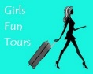
Lee & Anita The GFT Team

